RC-Taíno 2

**Caribbean Prehistory Cultural Context s**

1. **Major Periods**
   1. Paleoindian Period (9500 B.C.E. - 5000 B.C.E.)
   2. Mesoindian Period (5000 B.C.E. - C.E. 1)
   3. Neoindian Period (ca. C.E. 1 - ca. C.E. 1500)
2. **Preceramic Subcultures**
   1. Casimiroid Culture (ca. 4000 B.C.E. - 2000 B.C.E.)
   2. Ortoiroid Culture (ca. 4000 B.C.E. - C.E. 200)
      1. Krum Bay Subseries (1500 B.C.E. - 200 B.C.E.
      2. Coroso Subseries (1000 B.C.E. - C.E. 200)
3. **Ceramic Subcultures**
   1. Saladoid Period (ca. 500 B.C.E. - C.E. 545)
      1. Hacienda Grande (250 B.C.E. - C.E. 300)
      2. Cuevas (C.E. 400 - C.E. 600)
      3. Prosperity (C.E. 1 - C.E. 350)
      4. Coral Bay-Longford (C.E. 350 - C.E. 550)
   2. Ostionoid Period (C.E. 600 - C.E. 1500)
      1. Ostionan Subseries (C.E. 600 - C.E. 1200)
      2. Elenan Ostionoid (C.E. 600 - C.E. 1200)
         1. Monserrate (C.E. 600 - C.E. 850)
         2. Santa Elena (C.E. 850 - C.E. 1200)
      3. Magens Bay-Salt River 1 (C.E. 600 - C.E. 1200)
      4. Chican (C.E. 1200 - C.E. 1500)
      5. Capá (C.E. 1200 - C.E. 1500)
         1. Esperanza (C.E. 1200 - C.E. 1500

**4. The Taíno**

**1.1 Paleoindian Period (ca. 9500 - 5000 B.C.E.):**

The El Jobo site in Venezuela is the earliest recorded Caribbean prehistoric site. Gordon Willey (1971) assumes that this culture is an offshoot of the North American Big Game Hunting (concentration on the hunting of Pleistocene megafauna) tradition.

Although the Lesser and Greater Antilles were home to various types of extinct Pleistocene megafauna, such as the giant ground sloth (Megaelocsus), no actual cultural remains pertain to them. Some authors have treated the occurrence of Pleistocene megafauna and an acknowledged lower sea level of nearly 20-meters that could facilitate travel between the northern coast of South American and the Antilles during the Paleoindian period as positive conditions for Paleoindian occupation (Veloz Maggiolo and Ortega 1976). However, no pre-5000 B.C.E. sites have been noted in the Greater or Lesser Antilles islands (Haag 1963:337).

**1.2 Mesoindian Period (ca. 5000 B.C.E. - C.E. 1):**

The cultures of the Mesoindian period of the Caribbean area were considered roughly equivalent to North American Archaic hunting and gathering cultures. This period was believed to begin ca. 5000 B.C.E. and ended for most of the Lesser and Greater Antilles about two thousand years ago. A people referred to by the early Spanish as Ciboney, utilizing a Mesoindian life style, continued to exist in extreme western Cuba until historic times. This period was characterized as representative of a hunting and gathering people, who increasingly became dependent on the littoral zones of the islands for subsistence (Willey 1976).

The first noted Mesoindian occupation in the Antilles was the Banwari culture, a small animal-hunting and shellfish-gathering phase from Trinidad (ca. 5000 B.C.E.), which appeared to have possibly moved up the Lesser Antilles to Puerto Rico, Hispaniola, and Cuba over time. Most of the sites excavated from this period are related in some manner to the utilization of shellfish. However, this might be due to a sampling error, since most of the past archeological work in the Antilles has concentrated on the coastal environment. The Banwari phase was noted for coastal shell midden sites, which yielded fresh water and salt water shells of Neritina virginea and the conch, Melogena, and, predominately, crab remains, bones of deer, peccary, small mammals, and fish. The stone tools consisted of ground stone pestles, manos, grooved axes, celts, and chipped projectile points and tools. The points were also made of bone, as were needles and fishing spears (Harris 1976).

Twice during the Mesoindian period (2700 - 2000 B.C.E. and 1500 - 600 B.C.E.), sea levels lowered, destroying the shellfish environments of the islands and causing a depopulation of coastal areas. The lack of sites from these periods may also be explained by the idea that, as the sea level dropped, the shellfish beds retreated and with this retreat followed the prehistoric peoples who subsisted on them as a major source of food. Therefore, sites for these two periods, if they exist, may now be underwater. One site of the Mesoindian period has been found in the U.S. Virgin Islands at the Krum Bay site.

In the islands of Cuba, Hispaniola, and Puerto Rico, where the greatest concentration of Mesoindian sites are found, these period sites tended to be coastal shell middens with artifact assemblages generally similar to the Banwari culture found on Trinidad. Rouse (1992) defined the Mesoindian period for the Virgin Islands and Puerto Rico as having two distinct series, the Ortoiroid, known principally from the South American mainland, with scattered finds of artifacts in the Virgin Islands and Puerto Rico to the Mona Passage; and the archaic Casimiroid series. The Casimiroid was further subdivided into the Courian subseries of Cuba, Haiti, Puerto Rico, and the Virgin Islands, and the Redondan subseries of Cuba (Righter 1992).

Mesoindian period sites are generally open camp sites of small shell middens found on or near the coast. The faunal material recovered consists of fresh and saltwater shellfish and remains of fish and sea and land mammals. There currently is no basis from the available information on these sites to indicate seasonal use of marine and land resources. Although the sites were almost entirely oriented toward the maritime environment, there appears to be a heavier reliance on land-based hunting resources in the earlier part of the Mesoindian period than in the latter part.

The Mesoindian tool assemblage consists of flaked stone tools (such as projectile points, awls and knives) and ground stone tools (such as celts, manos, and axes). Conch shells were made into vessels and plates.

Generally, in comparison with areas surrounding the Antilles, the Cuban material was stylistically more closely related to material from eastern Venezuela (Rouse 1970); whereas, the Hispaniola and Puerto Rican material seemed to be associated with material from Central America (Alegría et al. 1955; Rouse 1970). Therefore, it is believed that origins for settling the Caribbean were multiple, as opposed to a single source of origin for the Mesoindian cultures of the Antilles; or, there may have been a single culture with differing manifestations related to different environments.

**1.3 Neoindian Period (ca. C.E. 1 - C.E. 1500):**

This period, dating from ca. C.E. 1 to European contact, ca. C.E. 1500, was characterized by distinct cultural periods, which were originally separated on the basis of different ceramic styles and other cultural manifestations. The first group to immigrate into the Antilles were the Saladoid (C.E. 0 - 600) who brought horticulture (cassava, yucca, and maize) and pottery technology to the islands. It is generally accepted that they originated in the lower Orinoco River Valley before spreading throughout the Antilles pushing the Mesoindian groups to western Cuba (Willey 1976).

**white-on-red pottery** In reviewing this earliest of pottery-making cultures in the Caribbean, "the hallmark of the earliest pottery . . . is a style which includes a number of types that are white paint on a red background. This white-on-red may be traced to its ancestral home in northern Venezuela and probably indicates the movement of new peoples rather than the simple diffusion of new traits. However, there is little basis for believing that some of the white-on-red pottery was actually manufactured in Venezuela and imported into Puerto Rico" (Haag 1963:333-335).

**Ostionoid culture** It has been postulated that between C.E. 600 and 800, another surge of migrants came out of the Orinoco area and spread throughout the Antilles (Stevens-Arroyo 1988). Called the Ostionoid culture, it is separated from the preceding Saladoid culture by different pottery styles, involving less painted decoration and more incised decoration, and the creation of ceremonial centers containing ball courts (Alegría 1983). Within the area of Puerto Rico and the Virgin Islands, sub-regional cultures emerged and developed permanent settlements, some with associated ceremonial centers and ball courts.

Taíno **Culture** Later elaborations of the Ostionoid culture, referred to as Elenoid (C.E. 800 - 1150) and Chicoid (C.E. 1150 - ca. 1500), were established by Rouse and Allaire (1978) on the basis of ceramic styles. These later cultures and their people were called Taíno or Arawak Indians by the Spanish when contact occurred in the early sixteenth century. This Taino culture reached its peak shortly before European contact. Taíno culture is noted for large village sites of 1,000 to 5,000 people controlled by chiefdoms, with emphasis on the cultivation of yucca and cassava, with supplemental hunting and shellfish-gathering, and the creation of ball courts as ceremonial plazas with surrounding stones often inscribed with images of deities. These ball courts could serve as either internal pleasure games or if placed on the margins of caacique’s territories they could have been used ceremonially to settle intra cacique disputes. The ball courts on Hspaniola while fewer in number than those on Boriquen (Puerto Rico) were ten times as large (Wilson 1990:25). William F. Keegan (2007 has disputed Irving Rouse (1992) that the baseline of Taino settlement was Hispaniola and not Boriquenand perhaps the size of Hispaniola’s ballcourts belie this precedence. Religious artifacts, such as *zemi (cemi)*, or ancestral and stone mobilary images, were often found in context with these ceremonial sites, as well as distinctive polychrome and incised pottery styles and fine ground stone and shell work. In the latter part of this period white-on-red ceramics disappeared and plain ceramics with lugs shaped like human or animal heads are molded onto the rim of vessels. These features were believed to have originated in Mesoamerica and diffused to the Caribbean through northern South America.

**Carib Culture** Just a few hundred years prior to contact, the Taino had begun to be displaced from the Lesser Antilles by a new group of Orinoco River Valley migrants, the Caribs. By European contact (ca. C.E. 1500), the Caribs had occupied all of the Lesser Antilles (Righter 1992:26).

**2. Preceramic Subcultures:**

***2.1 Casimiroid Culture****.* The Casimiroid Culture has been proposed to have originated from Lithic or Archaic period cultures from either the Yucatán or Central America. It is presumed the people of this culture migrated by sea from the mainland to western Cuba via a Mid-Caribbean chain of islands, which is now submerged. They spread eastward through Hispaniola Island, where the earliest known sites of this culture are dated at ca. 4000 B.C.E. Recent investigations in a rock shelter on Mona Island have uncovered a Casimiroid-like assemblage of lithic tools, with an appropriate radiocarbon date of ca. 2380 B.C.E. Only one Puerto Rican site, the Cerrillo site in the extreme southwestern part of the island, exhibits Casimiroid-like lithic artifacts. The implications are that the Casimiroid culture came into the western end of the Greater Antilles and spread eastward only as far as extreme western Puerto Rico.

Casimiroid sites are generally noted for lithic artifacts manufactured of fine grained flint. These include core tools, blades, burins, awls, and scrapers, in addition to anvils and hammerstones. It is believed that the sites on Mona Island and western Puerto Rico date from the Barrera-Mordán Complex (3600 - 2000 B.C.E.). Little information is known on subsistence base of the Casimiroid culture.

***2.2 Ortoiroid Culture***. While the Casimiroid was a lithic culture that migrated from west to east through the Antilles, a contemporary lithic culture, the Ortoiroid, was the result of migration of another lithic culture from northern South America, north up the Lesser Antilles to the Virgin Islands, and thence westward into Puerto Rico. The earliest dated Ortoiroid culture site in Puerto Rico is the Angostura site, which is dated at ca. 4000 B.C.E. Rouse has proposed a Corosan and Krum Bay subseries of lithic period sites for Puerto Rico and the Virgin Islands, respectively.

*Krum Bay Subseries* (1500 - 200 B.C.E.). The Krum Bay subseries artifact assemblage is characterized by fairly fine-grained basalt flake tools, hammerstones, shell picks, partially ground stone celts, and beads and pendants of stone, bone, and shell. Krum Bay sites tend to be open habitation sites located near the shore. Subsistence remains indicated shellfish gathering, fishing, and hunting of birds and turtles were the major sources of food. The Krum Bay Subseries is noted on St. Thomas and St. John (Virgin Islands National Park), United States Virgin Islands, the north coast of Puerto Rico, and Vieques Island (Caño Hondo site) off the southeast coast of Puerto Rico.

*Coroso Subseries* (1000 B.C.E. - C.E. 200). The Coroso subseries was identified as a lithic or preceramic culture as early as the 1930s by Rouse. Sites tended to be located on all the coasts of Puerto Rico, in caves and at shell middens. Recent work indicates occupation also occurred in the interior of the island. The artifact assemblage of the Coroso subseries is characterized by hammerstones, pebble chop-pers, flake tools, shell scrapers, shell plates, and pebble grinders. Subsistence data indicates the early part of the Coroso culture saw a more generalized diet of turtle, crabs, fish, and shellfish, leading to a more specialized diet of shellfish in later times. Significant sites of the Coroso subseries are Cueva de María la Cruz (Loíza Cave), Cayo Cofresí, Coroso site, and Playa Blanca. Inhabitants lived on or near the coast, in both open and cave sites. Burials were placed underneath shell middens by digging through them until reaching subsoil.

**3. Ceramic Subcultures:**

**3.1 Saladoid Period*.*** Around the fourth century B.C.E., a new migration of people, whose culture exhibited traits of ceramics, agriculture, and sedentism, occurred from mainland South America northward up the Lesser Antilles (including the area now containing Virgin Islands National Park and Buck Island Reef National Monument) and west into Puerto Rico and Hispaniola. This culture, termed the Saladoid culture, appears to have established itself initially in the southernmost Lesser Antilles as early as 500 B.C.E., and reached the area of the Virgin Islands and Puerto Rico by 345 B.C.E. Radiocarbon dates for these two island areas indicate the Saladoid period, or Cedrosan sub-series, lasted from ca. 345 B.C.E. - C.E. 545. The relatively rapid movement of the Saladoid culture into the Lesser Antilles and the eastern half of the Greater Antilles appears to have displaced the earlier lithic period cultures as far as Cuba, where up until contact with Europeans in the sixteenth century, a pre-ceramic culture, called the Ciboney, continued to exist.

This early ceramic period is further subdivided by ceramic styles. On Puerto Rico, the subperiods are Hacienda Grande (250 B.C.E.- C.E. 300), and Cuevas (C.E. 400 - 600). In the Virgin Islands they are Prosperity (C.E. 1 - 350) and Coral Bay-Longford (C.E. 350 - 550). The Saladoid ceramic styles of Puerto Rico and the Virgin Islands showed significant influences from the Barrancoid styles of ceramics based in the lower Orinoco River Valley of Venezuela. It has been suggested that these influences were due to long distance trade between the two areas.

Shared ceramic techniques between these two areas include vessel forms, such as zoomorphic effigy vessels, trays, and platters (some depicting animals native only to South America), jars and bowls with D-shaped strap handles, censers, and bell-shaped vessels. Saladoid potters decorated their vessels with polychrome designs in white-on-red, white-on-red with orange slip, black paint, and negative-painted designs. A smaller number of ceramics were decorated with designs incised into the body of the vessels.

Diagnostic lithic artifacts of the Saladoid culture in both Puerto Rico and the Virgin Islands are pendants shaped like raptorial birds endemic to South America made from exotic materials, such as jasper-chalcedony, amethyst, crystal quartz, fossilized wood, greenstones, carnelian, lapis lazuli, turquoise, garnet, epidote, and possibly obsidian. The distribution of these artifacts throughout the Greater and Lesser Antilles and northern South America is indicative of a Pan-Caribbean trade network of raw and manu-factured goods. By about C.E. 600, however, these artifacts all but disappear.

Settlement patterns of the Saladoid culture tended to be on the flat coastal plains and alluvial valleys of Puerto Rico and the Virgin Islands, probably to utilize the maritime food resources and fertile soils for growing food crops, such as manioc, cassava, or yucca, and, to a lesser extent, maize. In the later part of the Saladoid period, there appears to have been an expansion into the mounTaínous interiors of the islands. Typical village patterns in Puerto Rico and adjacent islands consisted of a semi-circular series of mounded middens, frequently serving as the village cemetery, facing a central plaza. Excavations of these cemeteries show individuals were treated equally in terms of grave goods, an indication of an egalitarian society.

**3.2 Ostionoid Period**. While the Ostionoid period has been viewed as an initial migration of people from the Orinoco coastal area through the Antilles to Hispaniola and Puerto Rico, it involved integration with the already emplaced Saladoid culture and this hybrid evolved into the Ostionoid culture. So the Ostionoid period represents a continuation of Saladoid attributes in ceramics, agriculture, and village life. During this period cultural continuity between the Caribbean Islands and mainland South America diminished as viewed from the lack of inter-regional trade items in the archaeological record, such as exotic stone pendants, while concomitantly there is an increase in regional Caribbean ceramic styles and the size and complexity of communities. A ranked hierarchy of chiefdoms emerged to control specific regions.

*Ostionan Subseries* (C.E. 600 - 1200). The Ostionan subseries, like the earlier Saladoid period, is defined by the distribution of specific ceramic styles. These ceramics lack the polychrome-painted decoration of the earlier period and instead are decorated by polishing, red painted surface, appliqué and modeled designs (usually zoomorphic), and in the latter part of the subseries, horizontal bands of geometric line-and-dot incising. Based on the findings of ceramics specific to this subseries, the Ostionan is restricted geographically to the western half of Puerto Rico. Major sites include Boquerón, Calvache, Las Cucharas, Las Mesas, Llanos Tuna, Abra, Buenos Aires, Cañas, Carmen, Diego Hernandez, and Pitahaya.

Beginning about C.E. 600, the central plaza evolved into petroglyph-lined enclosures, or ball courts, called batey. The petroglyphs were a visual expression of the religiosity of the people since many were of mythological figures. These ball courts were built perhaps for contestants to settle regional disputes as well as for the public’s enjoyment. During this period personal items of a ceremonial nature such as pendants, *zemi* stones and ritual axes were carved and sculpted by specially gifted craftspeople. In particular, one class of *zemi* stones represented a continuing reverence for the ancestors.

*Elenan Ostionoid Subseries* (C.E. 600 - 1200). Contemporary with the Ostionan subseries on the western half of Puerto Rico was the Elenan Ostionoid subseries that was distributed over the eastern half of the island. Two ceramic styles for this subseries have been recognized in eastern Puerto Rico. The earliest is Monserrate (C.E. 600 850), and the other is Santa Elena (C.E. 850 - 1200).

The Monserrate ceramic style is essentially a development from the earlier Cuevas style, but without the elaborate decoration, such as polychrome painting. Decoration consisted of red- or black-painted geometric designs and strap handles. In the following Santa Elena period, ceramics are characterized by loss of strap handles, production of mainly bowl forms, the abandonment of painted decoration and polishing. Modeling and incising became the major ceramic decoration.

As with the Ostionan subseries, the larger Elenan Ostionoid subseries sites have associated ball courts. And some sites, like Tibes, have multiple plazas and ball courts. Major sites associated with the Elenan Ostionoid subseries are Tibes, Collores, and El Bronce.

Magens Bay-Salt River 1 (C.E. 600 - 1200). Contemporary with the Puerto Rican subseries of the Ostionoid period, in the Virgin Islands, is the Magens Bay-Salt River subseries. It was partially named after the type-site located at Salt River Bay National Historical Park And Ecological Preserve. The ceramics, stone artifacts, *zemis*, and ball courts found in the Virgin Islands at this time show continuity with the Elenan Ostionoid subseries of eastern Puerto Rico.

*Chican Subseries* (C.E. 1200 - 1500). The last three hundred years of prehistoric occupation in Hispaniola, Puerto Rico, the Bahamas and Cuba may be traced to the Taíno proto-historic culture first encountered by the Spanish on the Bahamas.

Around C.E. 1200, a new ceramic style, called Boca Chica, emerged in the area of southeastern Hispaniola (present day Haiti and the Dominican Republic). This style is characterized by complicated vessel forms, surface polishing, relatively few red-painted vessels, and elaborate incised, modeled, and punctated designs. Trade ware of elaborately incised Boca Chica ceramics are found in Hispaniola and Puerto Rico.

1. **The Taíno**
2. The Taíno, an Arawak people who spoke the Taíno language, were indigenous to the Caribbean and the principal inhabitants of most of Cuba, Jamaica, Hispaniola (the Dominican Republic and Haiti), and Puerto Rico. A sub-group, the “Lucayans” (from the Taíno *Lukku-Cairi* or "people of the islands”) were the initial inhabitants of the Americas encountered by Columbus in the Bahamas (Albury 1975:5, 13–14; Craton 1986:17; Keegan 1992:11).

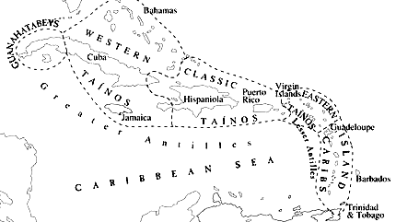

Fig. 1. Major cultural groups in the Caribbean, ca. 1492 (after Reid 2009: T-p.).

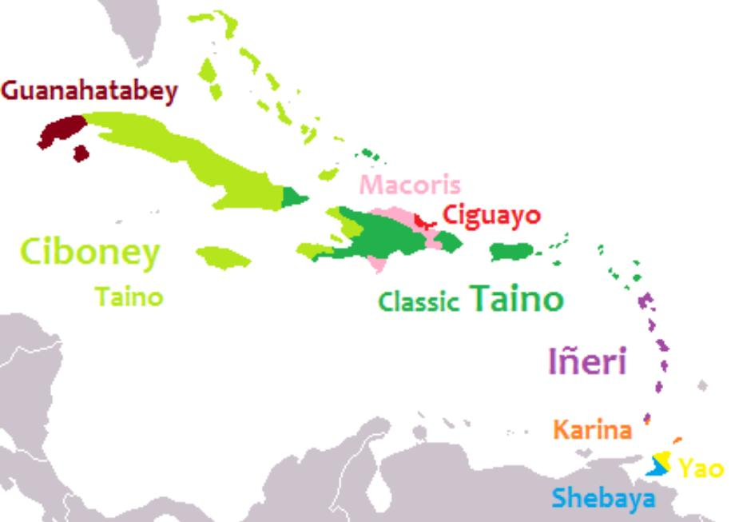

Fig. 2. Languages of the Caribbean, ca. 1492 (after Granberry and Vescelius 2004).

The ancestors of the Taíno had originated from the Yanomama homeland in the Amazon. However, these ancestors also had haplogroup A that the Yanomama lack, so there must have been another, as yet unknown, Taíno ancestral group with haplogroup A (Martínez-Cruzado 2001). The migrating ancestral group of women had a constrained mitochondrial (mtDNA) diversity. This suggests that these women had a homogeneous genetic lineage, and that the migration into the Caribbean was a genetically homogeneous stream that followed the Antilles to Hispaniola and Puerto Rico (Lalueza-Fox 2001; Keegan 2007: 57). In the Caribbean, meanwhile, archaic Casimiroid people, who had been in Hispaniola for over 4,000 years, also integrated with the mew immigrant Ostionoid people, ca. 600 C.E. Ostionoids were farmers, potters, and villagers with socially complex societies, while the archaic Casimiroids were expert fishers, hunters and gatherers with an expert knowledge of the insular flora and fauna. Together they evolved the hybrid Mellacoid (or Meillacan) culture that retained much of the Casimiroid knowledge of and veneration for the creatures and plants of the land and the sea (Wilson 2007: 101). These creatures became the subjects of their zoomorphic appliqué designs in their pottery which was often decorated with rectilinear incisions, crosshatched designs and punctuations.

Ostionan pottery is characterized by simple black smudging, very basic modeling, and an orange red slip applied to the whole of the typically thin and hard ceramic vessel. It is widely referred to as redware.

The Meillacan succeeded the Ostionan people in the Cibao valley of northern Hispaniola. About C.E. 800, the Meillacan people moved into Jamaica and Cuba, following the trail of their Ostiones forebears. The Meillacan people made unpainted pottery, often decorated with rectilinear incisions, crosshatched designs, punctuations, appliqué clay ridges, and small geometric and zoomorphic lugs.

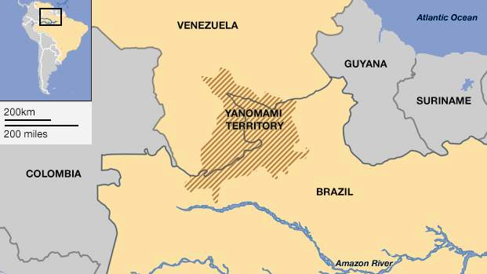

Fig. 3. Yanomami territory the putative origin of the ancestors of the Taíno (after the Hutukara Yanomami Association, The Venezuelan Government.

At the time of contact, the Taíno were divided into three broad groups. Those who spoke a Ciboney dialect were known as the Western Taíno and inhabited Jamaica, most of Cuba, and the Bahamas. Those who spoke the Classic Taíno dialect were both the Classic Taíno who inhabited Hispaniola and Puerto Rico and the Eastern Taíno who inhabited the northern Lesser Antilles. Caribs of the southern Lesser Antilles spoke Ineri an unrelated language and were the traditional enemies of the Taíno.

Many Taíno words passed into Spanish in the fifteenth century. As the language of first contact, Taíno was one of the most important sources of Native American vocabulary in Spanish, involving hundreds of words for unfamiliar plants, animals, and cultural practices, and through Spanish to other European languages such as French and English. Below is a sample of English words derived from the Taíno (Granberry 2004: 101-122).

| **Ta**í**no** | **Meaning** | **English** | **Ta**í**no** | **Mning** | **English** |
| --- | --- | --- | --- | --- | --- |
| barabakoa | cooking frame | barbecue | hurakã (/hodakã/?) | storm? | hurricane |
| kasikɛ | chief | cacique | iwana | iguana | iguana |
| kaimã | crocodile | caiman | mahis, máhisi | maize | maize |
| kaniba | Carib | cannibal | manatí | manatee | manatee |
| kanowa | boat | canoe | papaya | papaya | papaya |
| kasabi | cassava | cassava | batata | potato | sweet potato |
| kaya | island | cay | sabana | less trees | savanna |
| seiba | ceiba tree | ceiba | taí-no | good people | Taíno |
| wayaba | guava | guava | tabako | tabacu | tobacco |

**Taíno society**

Taíno society had two classes, *naborias* (commoners) and *nitaínos* (nobles). Male chiefs, *caciques*, who were advised by priests/healers known as *bohiques*. Caciques who were the chieftains of each of the island districts wore pendants of which some were of reddish copper-gold or *guanín*. Most of these were smelted down by the Spanish to send back to their Spanish royals to account for their apparent by delusional success in finding the gold that could pay off the debt incurred by the extirpation of the Jews and the Muslims from Spain in 1492. However, a number of stone artifacts, that to the Spanish had no value, have survived fortunately.

The first category of stone artifacts that we shall deal with includes three-pointed stones usually of heavy andesite (also referred to as tripointers) and have been divided into four categories by Jesse Walter Fewkes (1907:111-132) plus a type 5 that we have been able to identify from eastern Hispaniola.

**Type 1.** The first is the “type with head on anterior and legs on posterior projection. … The axis of the base is sometimes warped , now to one side now to the other, suggesting rights and lefts, but as a rule is generally straight. The surface is generally smooth, but in some specimens is marked by incised decorations, pits, and in one instance by a few wart-like excresences. Remnants of a superficial paint or pitch are found on two specimens. Only in rare instances … are anterior as well as posterior limbs cut on the stone. The classification of this type is based mainly on the form of the head” (Fewkes 1907: 111).

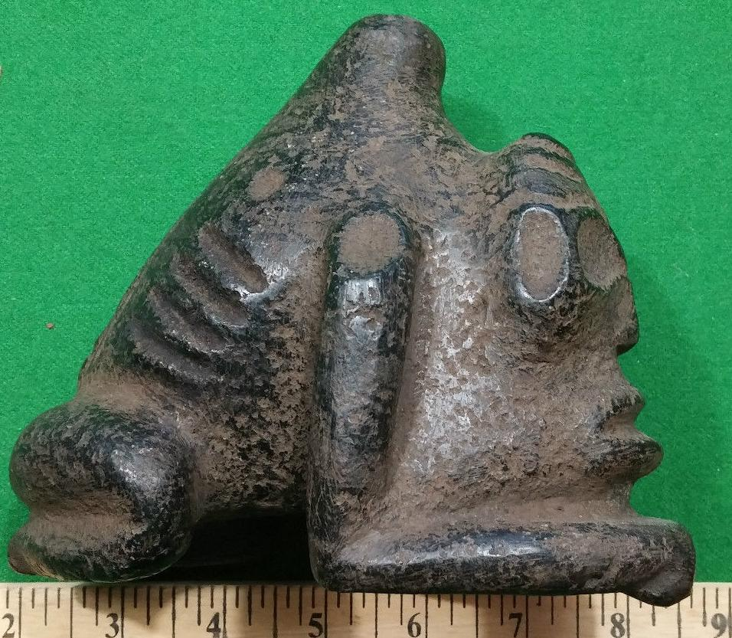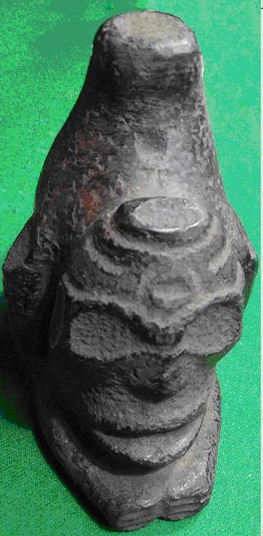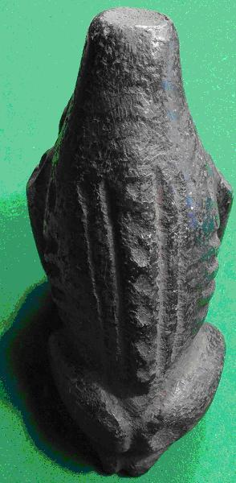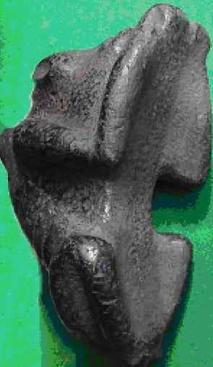

Fig. 4. Three-pointed Stone, Type 1, rare type, anterior and posterior limbs but feet undeveloped, and axis of the body straight. Type 1, Group 1 with human head. (Atlantika Collection no. F1969 .F4.1 )

The pointed protuberance on top of the sculpture in Fig. 4. ( Three-pointed Stone, Type 1), has been likened to either a volcanic cone or the male generative organ. The ribs are clearly shown suggestive of fasting which when combined with the enlarged eyes and the non-existent feet suggests a sedentary goal of visionary quest. The spinal column has marked each of the vertebrae as small cupules. Once cupule on the forehead is encircled with two concentric circles, the sign of a living being or life. Its underside is grooved to fit a curved object such as a stone collar that we shall examine shortly. A single lash could have easily encircled the three-pointed stone to the collar in its middle as had been shown for a similar artifact by Fewkes with a double lash at either end (1907: Plate LXIXa).

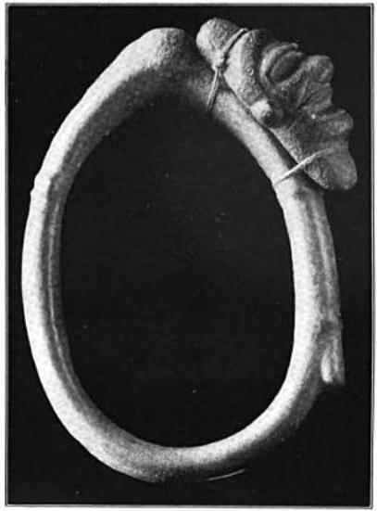

Fig. 5. Stone collar showing method of attachment of a grooved three-pointed stone. Collar, 16.5 in. dia. (after Fewkes (1907: Plate LXIXa).

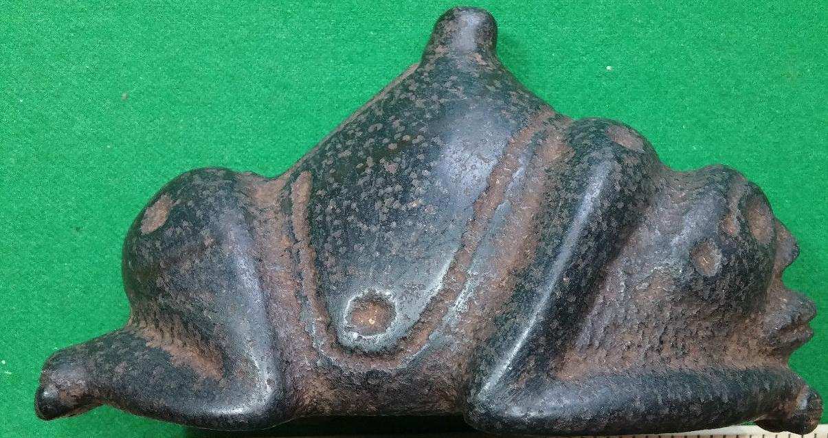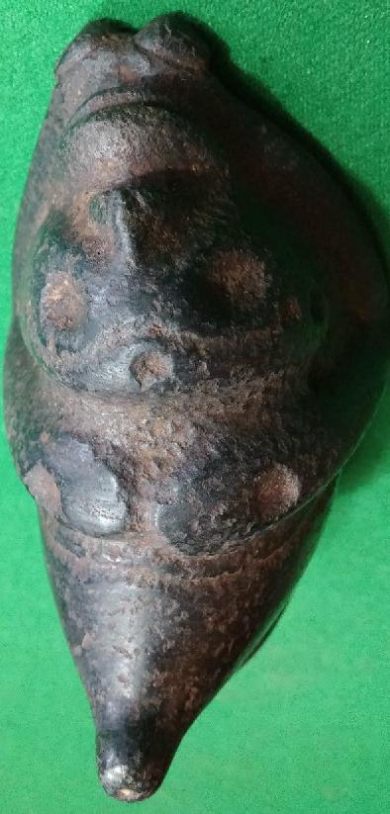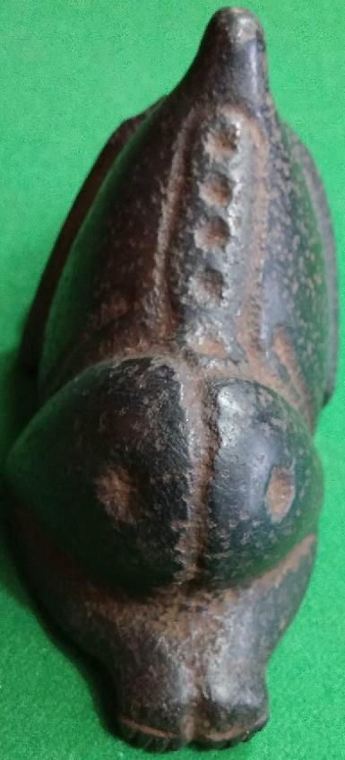

Fig. 6. Three-pointed Stone, Type 1, rare type, anterior and posterior limbs with feet developed, Group 1 with human head. And axis of the body skewed to the right (Atlantika Collection no. F1969 .F4.2 )

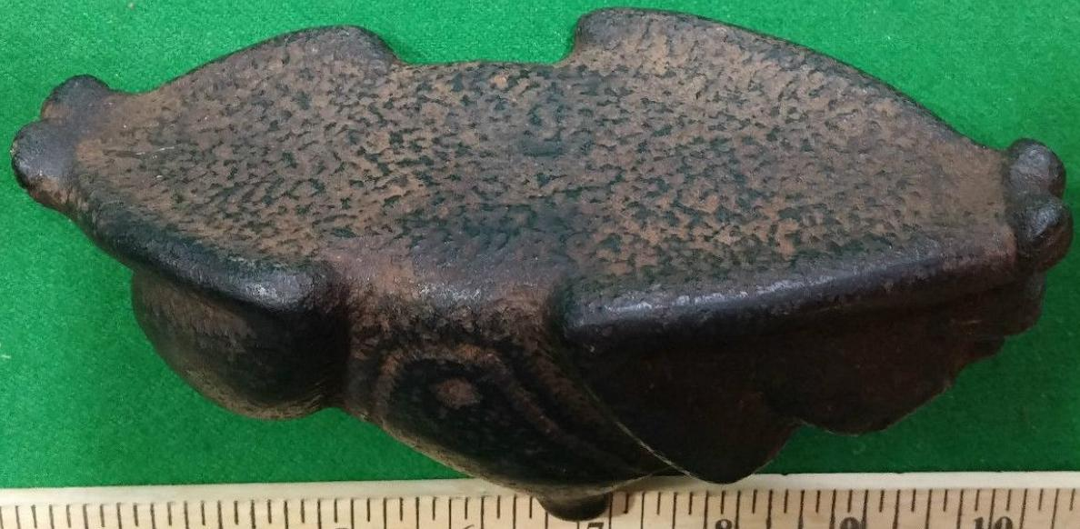

Fig. 6. Three-pointed Stone, Type 1, rare type, Group 1 with human head, underside showing rudimentary grove made by anterior and posterior limbs but flat base and midriff groove (Atlantika Collection no. F1969 .F4.2 )

Fig. 6 shows another Three-pointed Stone, Type 1 this time with the feet developed and with a slight skew to the right. In this sculpture these is no hint of ribs being exposed , and the yes are much smaller than in the three-pointed stone in Fig. 4. the feet are well developed, but the underside shows a much less developed groove to make an attachment to a stone collar, but there is a midriff groove made by the anterior and posterior appendages that could have been used to secure it onto a flat surface. This might have been accommodated by a stone collar with a flat surface area made specially for such a Three-pointed stone flat platform.

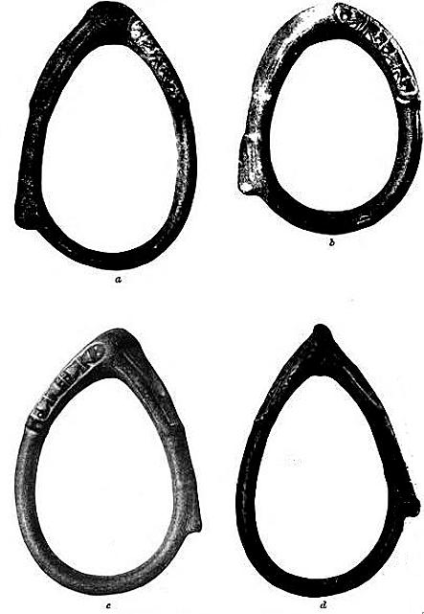

Fig 7. Slender ovate stone collars with a flat platform (Latimer collection) (after Fewkes 1907, PL. LXVI. a. 18.5 by 12.5 inches, b., 18 by 12.5 inches, c. 17.75 by 11.75 inches, 18.5 by 12.5 inches.

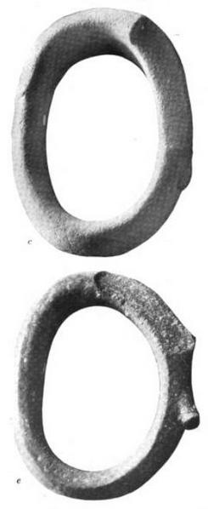

Fig.8. Massive stone collars that appear to have been purposefully abraded with a flat platform to accept a flat platform tree pointed stone. c. 17.5 inches, e, 14.75 by 9 inches. Fewkes 1907, PL. LXV.

What more can we say in comparison of these two three-pointed stones? First, they were both made to be worn by participants on stone collars .The one in Fig. 4 appears to be connected in some way with a spiritual rite associated with a visionary quest denoted by the exposed ribs (suggesting abstinence) and large eyes suggesting spiritual insight and a nocturnal environment). The three-pointed stone in Figs. 5-6 suggests an active persona denoted by delineated feet and eyes pointed ahead as if scrutinizing the landscape in sunlight, both of which criteria would be required for those playing the ballgame. It is therefore tentatively suggested that these two three-pointed stones served different ceremonial purposes, one nocturnal and spiritual and the other associated with daylight and activity.

Type 2. Type with face between anterior and conoid projections.

In 1907 Fewkes remarked that there were only a few examples of this type. The Atlantika collection contains 5. Fewkes remarked that “in some of these objects there is a pronounced ridge extending on each side extending from the apex of the cone to the margin of the base. The anterior of the apex of the conoid projection is pronounced in most of the specimens.

Type 3. Type with conoid projection modified into a head.

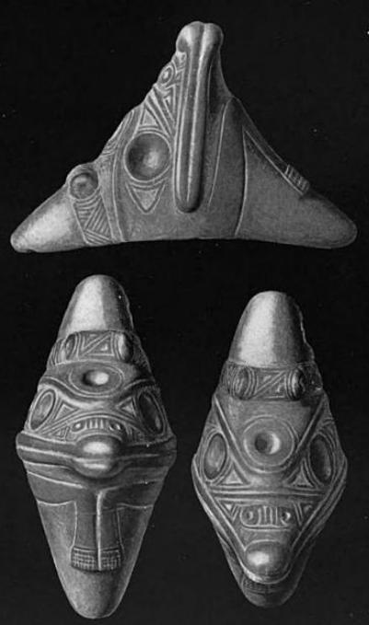

Fig. 9. Type with conoid projection modified into a head. (Fewkes 1907:125-127). This is considered by Fewkes as the rarest type, and 3 of the 4 examples that are in the Smithsonian originated in Santo Domingo. However our type 5 has only two examples, one of stone and one of shell.

**Type 4. Smooth stones**

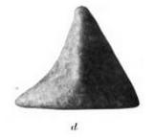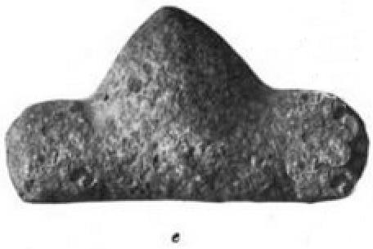

These two types (probably early examples of three-pointed stones) of smooth stones exhibit two different aspects of the three-pointed stone repertory. d (3 1/8 by 4 5/8 inches) shows an early predilection to pointing anteriorly as in Type 2. e (8 by 4 1/2 inches) shows a rudimentary platform to be affixed to a stone collar or other device. Both are early and diminutive types.

**Type 5 . Stone with suficial abstract markings**. This type is an addition to Fewkes’ typology and represents only one example.in stone and one example in shell.

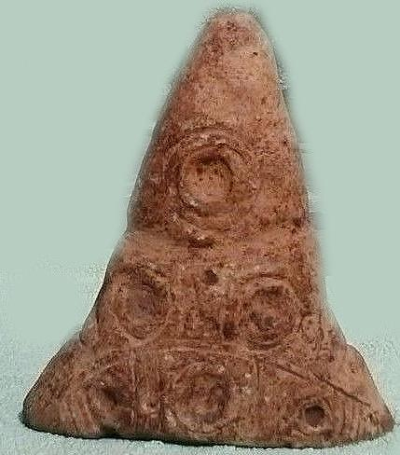 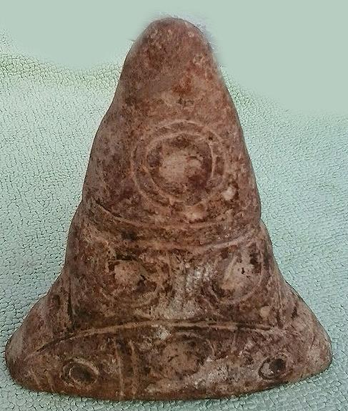 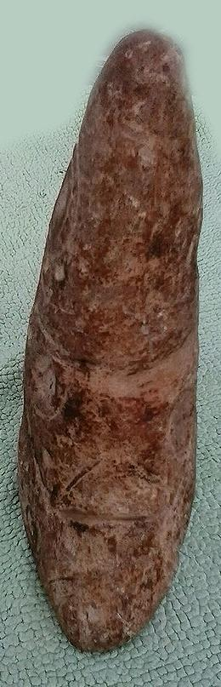

Type 5. 7.5 by 6 by 2 inches; country of origin, Dominican Republic. (Atlantika Collection no. F1969 .F4.3 )

In Type 5 the designs are composed of three elements: a central cupule encompassed by two concentric circles. It has been established that this symbolism signifies life. There are six of these symbols on either side. An upper cupule is separated from two middle cupules by two circular lines that encompass the entire conoid. The two middle cupules are separated from the three lowest cupules also by two inverted circular lines. Perhaps what is being expressed here in Taíno geometry is a tripartite, living universe, the upper sky which is alive with the solar disk, the middle region of earth which is alive with animals and plants and fishes, the lower, nether or dark regions which are alive with the ancestors represented on earth by their cemis. The geometric symbolism implicit in Type 5 appears to conform to the iconography implicit in other artifacts we shall examine, especially cemis and pendants.

**Cemieism.**

Father Pané delineated twelve different types of cemis The Jeronymite Friar José Juan Arrom (1975). . paired each type with its surviving visual examples. The Taino tripartite layered cosmos as shown by Father Pané included sky, earth and lower world and this is indicated on our Type 5 three-pointed stone.

The Taíno high god, Yaya, encompassed omnipotence, immortality and was born *sui generis*. In our Type 5 three-pointed stone he is represented as the highest cupule surrounded by two concentric circles.

The two encircling lines that separate him from the middle earthy life are important for they indicated that he is distant from every-day life. To fill this gap intermediaries are invoked However, there is a special way they are invoked, for the personages of Ta*ino* myths are distinguished from cemi spirits to which they must be paired. In Pané’s prologue Yucahú and Attabeira are presented as “middle earth” intermediaries. Since sociology often mirrors the religious theology, these two intermediaries mirror the l personages who can intercede on the level , for instance, of the cacique, the district chieftain, to the high chieftain of the island.

Yucahú is male and as the male intermediary to the spiritual high chieftain he embodies male virility and power. His other name is Yaca huguamá

and had living in square *bohíos,* instead of the round ones of ordinary villagers, and sitting on wooden stools to be above the guests they received ([*"Caciques, nobles and their regalia"*](http://web.archive.org/web/20061009090513/http://elmuseo.org/taino/caciques.html). elmuseo.org. Accessed 12.15.2015) from [*the original*](http://www.elmuseo.org/taino/caciques.html). *Bohiques* were extolled for their healing powers and ability to speak with gods. They were consulted and granted the Taíno permission to engage in important tasks.

The Taíno had a [matrilineal](https://en.wikipedia.org/wiki/Matrilineal) system of [kinship](https://en.wikipedia.org/wiki/Kinship), descent and inheritance. When a male heir was not present, the inheritance or succession would go to the oldest male child of the deceased's sister. The Taíno had [avunculocal](https://en.wikipedia.org/wiki/Avunculism) post-marital residence, meaning a newly married couple lived in the household of the maternal uncle. He was more important in the lives of his niece's children than their biological father; the uncle introduced the boys to men's societies. Some Taíno practiced [polygamy](https://en.wikipedia.org/wiki/Polygamy). Men, and sometimes women, might have two or three spouses. A few caciques had as many as 30 wives.

At the time of Columbus' arrival in 1492, there were five Taíno chiefdoms and territories on Hispaniola, each led by a principal *Cacique* (chieftain), to whom tribute was paid. *Ayiti* ("land of high mountains") was the indigenous Taíno name for the mountainous side of the island of Hispaniola, which has retained its name as *Haïti* in French.

Cuba, the largest island of the Antilles, was originally divided into 29 chiefdoms. Most of the native settlements later became the site of Spanish colonial cities retaining the original Taíno names, for instance; Havana, Batabanó, Camagüey, Baracoa and Bayamo (Dacal Moure and Rivero de la Calle 1997: 26, fig. 9). “Cuba” derives from the Taíno *cubao* "abundant fertile land" or *coabana* "great place".

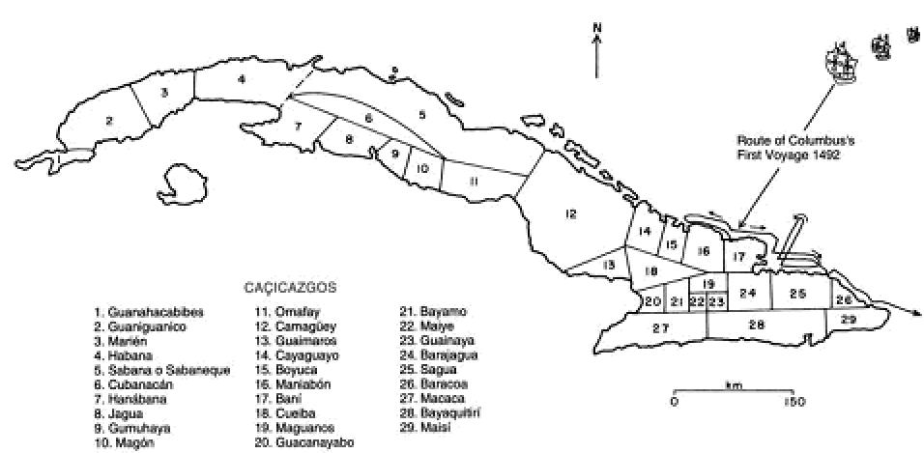

Taíno Cacicagos in Cuba in 1492.

Puerto Rico also was divided into chiefdoms. As the hereditary head chief of Taíno tribes, the cacique was paid significant tribute. At the time of the Spanish conquest, the largest Taíno population centers may have contained over 3,000 people each.

Contact of the Taínos with the Carib culture was a major challenge to the ruling elites of the Taíno homeland. The Caribs had either migrated from the Orinoco area of South America or had evolved from the Arawaks in the Lesser Antilles or perhaps a combination of both. In any case they challenged the cacique system as it had evolved on the individual Taíno islands, and the Spanish noted the Taíno of Hispaniola and Puerto Rico were engaged in resisting Carib attacks (Saunders 2005:xi, xv).

It is believed that Taínos from eastern Hispaniola settled on the southern coast of Puerto Rico and introduced Chican trade wares thereby spreading their cultural influence. This may indicate that certain Taíno *caciques* were trying to establish extra-insular hegemonies. This expansionism may have been the result of the Neo-Atlantic Altithermal Climatic Period (800-1250) in which there was increased rainfall and a longer growing season in North America, Central America and the Caribbean. During this period there was increased crop production, which is measured by palynology (the study of plant pollen in archaeological sites), and rapid population growth, which is measured by site numbers and the size of sites. There appears to be a clustering of large sites around major ceremonial centers. This suggests these sites were centers of concentrated religious and political power that extended over large territorial units. As populations expanded on the islands extra-insular sites became attractive and this would have put the Taínos in competition with the Caribs as they moved further south along the line of the Antilles chain of islands.

**Taíno Religion, Its Practice and Associated Ceremonial Objects**

Taíno religion revolved around a supreme creator god and a fertility goddess. This balance was mirrored in Taíno society, which was matrilineal. The creator god **Yúcahu** (**Yukajú**, **Yocajú**, **Yokahu** or **Yukiyú)** was the masculine fertility spirit and one of the supreme zemís or deities with his mother [Atabey](https://en.wikipedia.org/wiki/Atabey_(goddess)) who was his feminine counterpart (Rouse 1993, p.13 ). Dominant in the [Caribbean](https://en.wikipedia.org/wiki/Caribbean) region at the time of Columbus’ First voyages of Discovery, the peoples associated with Taíno [culture](https://en.wikipedia.org/wiki/Culture) inhabited the islands of the [Bahamas](https://en.wikipedia.org/wiki/Bahamas), the [Greater Antilles](https://en.wikipedia.org/wiki/Greater_Antilles), and the [Lesser Antilles](https://en.wikipedia.org/wiki/Lesser_Antilles) is [Yúcahu Maórocoti](https://en.wikipedia.org/wiki/Yukiyu) and he governs the growth of the staple food, the [cassava](https://en.wikipedia.org/wiki/Cassava). The goddess is [Attabeira](https://en.wikipedia.org/wiki/Atabey_(goddess)), who governs water, rivers, and seas. Lesser deities govern natural forces and are also zemís (Bercht et al. 1997:23). Boinayel, the Rain Giver, is one such zemi, whose magical tears become rainfall (Heilbrunn 2006).

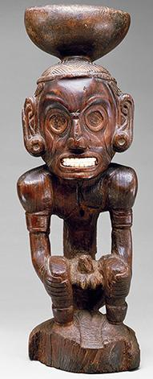

## Deity Figure (Zemí)

Date: ca.1000

Geography: Dominican Republic (?), Caribbean

Culture: Taíno

Medium: Wood (Guaiacum sp.), shell

Dimensions: H. 27 x W. 8 5/8 x D. 9 1/8 in. (68.5 x 21.9 x 23.2cm)

Classification: Wood-Sculpture

Credit Line: The Michael C. Rockefeller Memorial Collection, Bequest of Nelson A. Rockefeller, 1979

Accession Number: 1979.206.380

This striking figure of a crouched, emaciated male figure clutching his knees was called a *zemi* or idol by the Taino people. *Zemis* were the most important cult objects in their society. Symbolizing social status, political power, and fertility, they represent deities worshipped by the Taino, including ancestors and the forces of nature. Produced in different forms and sizes in wood, clay, stone, shell, and bone, *zemis* were kept in special shrines in Taino villages and used in ceremonies that included the taking of *cohoba*, a hallucinogenic snuff. *Cohoba* snuff, made from the seeds of a local tree, is one of the strongest indigenous American hallucinogens. For ceremonies, it was often mixed with crushed shell and/or tobacco to enhance its effects. Placed on the plate on top of the *zemi*'s head, the mixture was inhaled through tubes to the nostrils. Visions resulted which the Taino perceived as apparitions and messages of their gods and ancestors.

The Tainos believed that a pair of *zemis* were responsible for the sunshine and rainfall respectively. This figure is thought to portray Boinayel, the Rain Giver, the deep grooves running down from his eyes symbolizing the magical tears that created rainfall.

Spirits of ancestors, also zemis, were highly honored, particularly those of [caciques](https://en.wikipedia.org/wiki/Cacique) or chiefs. Bones or skulls might be incorporated into sculptural zemis or [reliquary](https://en.wikipedia.org/wiki/Reliquary) urns. Ancestral remains would be housed in shrines and given offerings, such as food.[9](https://en.wikipedia.org/wiki/Zemi" \l "cite_note-b23-2) Bercht et al. 1997: 23).

*Cohoba* is a Taíno transliteration for a ceremony in which the ground seeds of the cojóbana tree were inhaled in a twin-nasal, Y-shaped pipe (also called *Cohoba*), producing a psychedelic effect (Aquino 1977). The *cojóbana* seeds contain Bufotenine (N,N-Dimethylserotonin, see PubChem CID: 10257) a tryptamine related to the neurotransmitter serotonin found in the parotoid glands of some species of psychoactive toads, most notably *Incilius alvarius*. Bufotenine is also present in some mushrooms and higher plants, such as *Yopo* or *Anadenathera peregrina* (Schultes 1976). Conversely, *Cohoba* may have been a generalized term for hallucinogens, including toxic *Datura* and related genera (*Solanaceae*). The Taíno term for the corresponding ceremony using *Cohoba*-laced tobacco is *cojibá*. The practice of snuffing *Cohoba* was popular with the Taíno and Arawakan peoples. (Torres 1998)

The Cemi.

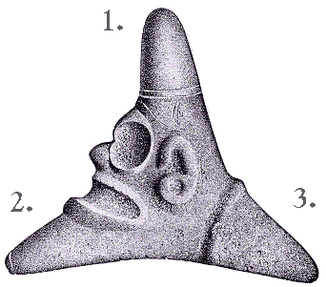

The Cemi stone, with its three cardinal points, is a fundamental symbol in the Taíno religion. Many Taínos name the three points "Yocahu Bagua Maorocoti," which is another word for the Creator, Yaya, as represented by the world's indigenous peoples at the time of the coming of Guamikinas (the European "covered people").

1. On top of this sacred mountain peak, in the turey (sky) of the four directions, resides Yaya - the Creator, whose name means that which has neither beginning nor end and which has no male ancestor or creator.

2. Coabey, is the underworld, the place of the dead. Here resides Hupia, the spirit of the dead. The face of Guayaba, the Chief of Coabey, is represented here.

1. The land of the living. Here resides Goiz, the spirit of living people

They call him Yúcahu Bagua Maórocoti" is the earliest mention of the zemí taken from the first page of Fray Ramón Pané's *Account of the Antiquities of the Indians*.[[5]](https://en.wikipedia.org/wiki/Yúcahu" \l "cite_note-5) As the Taíno did not possess a written language, the name is the phonetic spelling as recorded by the Spanish missionaries, Ramón Pané, and [Bartolomé de las Casas](https://en.wikipedia.org/wiki/Bartolomé_de_las_Casas). The three names are thought to represent the Great Spirit's epithets. Yúcahu means spirit or giver of cassava. Bagua has been interpreted as meaning both "the sea" itself and "master of the sea." The name Maórocoti implies that he was conceived without male intervention.[[6]](https://en.wikipedia.org/wiki/Yúcahu" \l "cite_note-Pane-6)[[7]](https://en.wikipedia.org/wiki/Yúcahu" \l "cite_note-Arroyo-7)[[8]](https://en.wikipedia.org/wiki/Yúcahu" \l "cite_note-Rouse-8) He was also later known as "El Gigante Dormido", or "Sleeping Giant".

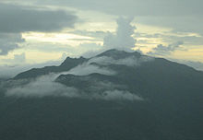

[El Yunque peak](https://en.wikipedia.org/wiki/El_Yunque_(Puerto_Rico)) in Puerto Rico is the mythological dwelling of Yúcahu.

The Taíno had a well developed [creation myth](https://en.wikipedia.org/wiki/Creation_myth), which was mostly passed down via oral tradition. According to this account, in the beginning there was only [Atabey](https://en.wikipedia.org/wiki/Atabey_(goddess)), who created the heavens. However, there was still a void, where nothingness prevailed. The heavens were inactive and any action was meaningless. Earth and the other cosmic entities laid barren. Despite being dominated by darkness, [Atabey](https://en.wikipedia.org/wiki/Atabey_(goddess)) herself failed to notice that this universe was incomplete. Eventually she decided to create two new deities, Yucáhu and Guacar, from magic and intangible elements. [Atabey](https://en.wikipedia.org/wiki/Atabey_(goddess)) now felt confident that her creation could be completed and left it in charge of her sons. Yucáhu took over as a creation deity, becoming a universal architect and gathering the favour of his mother. From his dwelling in the heavens, he contemplated and awoke the Earth from its slumber. As part of this process, two new deities emerged from a cave. Boinael and Maroya, controlling the sun and moon respectively, which were tasked with illuminating the new world day and night. No longer would the Earth be shrouded by darkness. Yucáhu was satisfied with his work, but in a fit of jealousy Guacar hid within the heavens, never to be seen again. Now bored, Yucáhu roamed and noticed four gemstones that lied in the ground, which he took and converted into the celestial star beings Racuno, Sobaco, Achinao and Coromo, who reproduced and spread throughout the universe, where they guide the deities. He followed this by creating animals, granting them dwellings and teaching them how to live. Yucáhu then had a revelation, believing that something else should complete his creation. Convinced that the new entity should be neither animal nor deity, he pondered this profoundly. Yucáhu then opened a rift in the heavens from which emerges the first man, whom he granted a soul and named Locuo. This man would roam the Earth endlessly filled by joy and thanking the deity for his creation. Finally satisfied with his creation, Yucáhu left the world in the hands of humanity, feeling that balance had been reached.

Yúcahu became known as the deity of [agriculture](https://en.wikipedia.org/wiki/Agriculture), as well as the semi of peace and tranquility, he represented goodness. This was contrasted greatly by the goddess Guabancex (more commonly, but erroneously, known as [Juracán](https://en.wikipedia.org/wiki/Juracán)) whose fierce nature was regarded as responsible for persuading other semis in other to bring forth chaos and who was associated with the more aggressive [Caribs](https://en.wikipedia.org/wiki/Island_Caribs). Yúcahu was believed to have a throne in [El Yunque peak](https://en.wikipedia.org/wiki/El_Yunque_(Puerto_Rico)), the largest mountain found in the tropical [El Yunque National Forest](https://en.wikipedia.org/wiki/El_Yunque_National_Forest) reserve, where he resided in the same manner that the [Greek gods](https://en.wikipedia.org/wiki/List_of_Greek_mythological_figures) did in [Mount Olympus](https://en.wikipedia.org/wiki/Mount_Olympus). The Taíno referred to the peak as *yuké*, or "The White Lands", in reference to the tick cloud shroud that always surrounds it. This mountain range diverts the wind of hurricanes, minimizing the damage that the storms do to the lower parts of the island. Noticing this, the natives interpreted this as Yúcahu confronting Guabancex and her cohorts over the safety of his worshipers. Located in the northern mountains of Puerto Rico, the region where El Yunke is located was originally known as "Yukiyu", a name that became associated with the deity. Following the Spanish colonization, it became known under the Hispanized variant of [Luquillo](https://en.wikipedia.org/wiki/Luquillo,_Puerto_Rico) a name that remains in use.

## References

• Fray Ramón Pané 1999, p.4

• • Stevens-Arroyo 2006, p.221

• • Rouse 1993, p.13

• • Rouse 1993, p.5

• • Fray Ramón Pané was the first European missionary to arrive in the New World and the first to learn the native language. He was the first person who studied the beliefs of an indigenous people, and his account was the first book to be written by a European on American soil.

• • Pané 1999

• • Stevens-Arroyo 2006

* 1. • Rouse 1993

### Bibliography

* Fray Ramón Pané (1999). José Juan Arrom, ed. An Account of the Antiquities of the Indians. Susan C. Giswold (trans.). Durham, NC ;London: Duke Univ. Press. [*ISBN*](https://en.wikipedia.org/wiki/International_Standard_Book_Number) [*978-0-8223-2347-1*](https://en.wikipedia.org/wiki/Special:BookSources/978-0-8223-2347-1). A New Edition, with an Introductory Study, Notes, & Appendixes by José Juan Arrom
* Arroyo, Antonio M. Stevens (2006). Cave of the Jagua : the mythological world of the Taínos (2. ed.). Scranton [u.a.]: Univ. of Scranton Press. [*ISBN*](https://en.wikipedia.org/wiki/International_Standard_Book_Number) [*1-58966-112-5*](https://en.wikipedia.org/wiki/Special:BookSources/1-58966-112-5).
* Rouse, Irving (1993). Tainos : Rise and Decline of the People Who Greeted Columbus (New ed.). New Haven: Yale University Press. [*ISBN*](https://en.wikipedia.org/wiki/International_Standard_Book_Number) [*0-300-05696-6*](https://en.wikipedia.org/wiki/Special:BookSources/0-300-05696-6).
* *[American Anthropologist](http://books.google.com/books?id=8HV0AAAAIAAJ&pg=PA356&dq=Yukiyú" \l "PPA354,M1)*. Original from the University of California: American Anthropological Association. 1909. pp. 354–356.

Zemis could be consulted by medicine people for advice and healing.[[4]](https://en.wikipedia.org/wiki/Zemi" \l "cite_note-cuba-4) During these consultation ceremonies, images of the zemi could be painted or tattooed on the body of a priest, who was known as a *Bohuti* or *Buhuithu*.[[5]](https://en.wikipedia.org/wiki/Zemi" \l "cite_note-5) The [reliquary](https://en.wikipedia.org/wiki/Reliquary) zemis would help their own descendants in particular.[[6]](https://en.wikipedia.org/wiki/Zemi" \l "cite_note-j193-6)

## Religious art

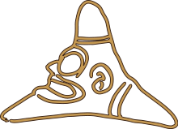

Drawing of a Taíno three-point zemi

Sculptural zemis, or "[amuletic](https://en.wikipedia.org/wiki/Amulet) zemis" take many forms,[[6]](https://en.wikipedia.org/wiki/Zemi" \l "cite_note-j193-6) but the most characteristically Taíno art form is the three-point stone zemi. One side of the stone might have a human or animal head with the opposite side having hunched legs. These are sometimes known as "frog's legs" due to their positioning. The fierce face of the creator god is often portrayed. Very small ceramic three-point zemis have been uncovered by archaeologists in the [Lesser Antilles](https://en.wikipedia.org/wiki/Lesser_Antilles), as well as [Colombia](https://en.wikipedia.org/wiki/Colombia) and [Venezuela](https://en.wikipedia.org/wiki/Venezuela), dating back to 200 BCE.[[3]](https://en.wikipedia.org/wiki/Zemi" \l "cite_note-b24-3) Small amuletic zemis would be worn on warrior's foreheads for protection in battle.[[6]](https://en.wikipedia.org/wiki/Zemi" \l "cite_note-j193-6)

Zemis are sculpted from a wide variety of materials, including bone, clay, wood, shell, sandstone, and stone.[[1]](https://en.wikipedia.org/wiki/Zemi" \l "cite_note-heil-1) They are found in [Cuba](https://en.wikipedia.org/wiki/Cuba), [Dominican Republic](https://en.wikipedia.org/wiki/Dominican_Republic), [Haiti](https://en.wikipedia.org/wiki/Haiti), [Jamaica](https://en.wikipedia.org/wiki/Jamaica), [Puerto Rico](https://en.wikipedia.org/wiki/Puerto_Rico), and other Caribbean islands. Some are quite large, up to 100 cm tall. Some are effigies of birds, snakes, alligators and other animals,[[4]](https://en.wikipedia.org/wiki/Zemi" \l "cite_note-cuba-4) but most are human effigies. Even twin human figures are portrayed.[[7]](https://en.wikipedia.org/wiki/Zemi" \l "cite_note-7)

Wooden zemis were preserved in relatively dry caves. It is believed that Taíno people hid their ceremonial objects in caves, away from the Spanish, or destroyed them to avoid having them fall into Spanish hands.[[8]](https://en.wikipedia.org/wiki/Zemi" \l "cite_note-b30-8)

### Beaded zemis

Two of the most elaborate surviving zemis are housed in European museums. One is a belt with a zemi from the [Greater Antilles](https://en.wikipedia.org/wiki/Greater_Antilles). The belt dates from circa 1530 and is made of cotton, white and red snail shells, black seeds, pearls, glass, and [obsidian](https://en.wikipedia.org/wiki/Obsidian). It is housed in the [Museum für Völkerkunde](https://en.wikipedia.org/wiki/Museum_of_Ethnology,_Vienna) in [Vienna](https://en.wikipedia.org/wiki/Vienna).[[9]](https://en.wikipedia.org/wiki/Zemi" \l "cite_note-Berecht_159-9)

The second is housed in the [Pigorini National Museum of Prehistory and Ethnography](https://en.wikipedia.org/wiki/Pigorini_National_Museum_of_Prehistory_and_Ethnography) in [Rome](https://en.wikipedia.org/wiki/Rome). Until 1952, it was wrongly labeled as an African fetish, but scholars have confirmed that it is Taíno from the early 16th century and exhibits elements of Caribbean, European, and African artistic influences.[[9]](https://en.wikipedia.org/wiki/Zemi" \l "cite_note-Berecht_159-9)

## Notes

• ["Deity Figure (Zemi) Dominican Republic; Taino (1979.206.380)"](http://www.metmuseum.org/toah/ho/08/canc/ho_1979.206.380.htm) In Heilbrunn Timeline of Art History. New York: The Metropolitan Museum of Art, 2000 October 2006; retrieved 22 September 2009

• • Bercht et al, 23

• • Bercht et al, 24

• • Corbett, Bob. [Arawak/Taino Related Myths.](http://www.cubaheritage.org/articles.asp?lID=1&artID=11) *Cuba Heritage.* (retrieved 19 Sept 2009)

• • Joyce, 195

• • Joyce, 193

• • Bercht, 8, 14, 18, 55, 92, and 123

• • Bercht et al, 30

* 1. • Bercht et al, 159

## References

* Bercht, Fatima, Estrellita Brodsky, John Alan Farmer, and Dicey Taylor. *Taíno: Pre-Columbian Art and Culture from the Caribbean.* New York: Monacelli Press, 1997. [ISBN 1-885254-82-2](https://en.wikipedia.org/wiki/Special:BookSources/1885254822).
* Joyce, Thomas Athol. [*Central American and West Indian Archaeology: Being an Introduction to The Archaeology of Nicaragua, Costa Rica, Panama and the West Indies.*](http://books.google.com/books?id=sEMTAAAAYAAJ&ots=kRhDAnjAZa&dq=Central American and West Indian Archaeology%3A Being an Introduction to The Archaeology of Nicaragua%2C Costa Rica%2C Panama and the West I ) New York: G. P. Putnam's Sons, 1916 (retrieved through Google Books, 19 Sept 2009).

## External links

* [Pigorini Museum zemi, ca. 1510-15, back view](http://www.smith.edu/vistas/vistas_web/espanol/gallery/detail/zemi-back_det.htm) | [front view](http://www.smith.edu/vistas/vistas_web/espanol/gallery/detail/zemi-front_det.htm)
* [Zemis in a museum exhibit](http://www.latinamericanstudies.org/taino/exhibit-zemis.htm)
* [Taíno zemi of Boinayel, Dominican Republic](http://www.metmuseum.org/toah/ho/08/canc/ho_1979.206.380.htm), Metropolitan Museum of Art
* [Beaded Zemi photo](http://www.art-platform.com/pics/Zemi Dominican Republic/1515 Beaded Zemi.html)

Postscript

The Spaniards, who first arrived in the Bahamas, Cuba, and Hispaniola in 1492, and later in Puerto Rico, did not bring women in the first expeditions. They took Taíno women for their common-law wives, resulting in mestizo children (Guitar 2001). Sexual violence in Hispaniola with the Taíno women by the Spanish was also common (Léger 1907). Scholars suggest there was substantial mestizaje (racial and cultural mixing) in Cuba, as well, and several Indian pueblos survived into the 19th century.

The Taíno became nearly extinct as a culture following settlement by Spanish colonists, primarily due to infectious diseases to which they had no immunity. The first recorded smallpox outbreak in Hispaniola occurred in December 1518 or January 1519 (Crosby 1972:47). The 1518 smallpox epidemic killed 90 percent of the natives who had not already perished (Abbott 2010). Warfare and harsh enslavement by the colonists had also caused many deaths (Chrisp 2006). By 1548, the native population had declined to fewer than 500.

## References

## **Abbot, Elizabeth (1 April 2010).** [***Sugar: A Bitterweet History***](http://books.google.com/books?id=aaxc1WdKmwEC)**. Penguin.**

Albury, Paul. 1975. *The Story of the Bahamas.* New York: MacMillan.

Alegría, Ricardo (April 1951). "The Ball Game Played by the Aborigines of the Antilles,” American Antiquity **16** (4): 348–352.

Aquino, Luis Hernández. 1977. Diccionario de voces indígenas de Puerto Rico. Río Piedras: Editorial Cultural.

Bercht, Fatima, Estrella Brodsky, John Alan Farmer and Dicey Taylor, eds. 1997. Taíno*: Pre-Columbian Art and Culture from the Caribbean*. New York: Museo del Barrio.

Chrisp, Peter. 2006. Christopher Columbus: Legendary Sailor and Explorer. London: DK Publishing.

Craton, Michael. 1962. *A History of the Bahamas.* London: Collins.

Crosby, Alfred W. 1972. *The Columbian Exchange* Westport, CT.

Guitar, Lynne. 2001. “Criollos: The Birth of a Dynamic New Indo-Afro-European People and Culture on Hispaniola.” KACIKE: Journal of Caribbean Amerindian History and Anthropology. Archived from the original on 16 Dec. 2015

Granberry, Julian and Gary S. Vescelius. 2004. *Languages of the Pre-Columbian Antilles.* Tuscaloosa: The University of Alabama Press.

Harris, Peter O'Brien. 1976. The Preceramic of Period in Trinidad. In *Proceedings of the First Puerto Rican Symposium on Archaeology*, edited by L. Robinson. Fundación Arqueológica, Anthropológica e Histórica de Puerto Rico, San Juan.

Heilbrunn Timeline of Art History. . 2006 ["Deity Figure (Zemi) Dominican Republic; Taino (1979.206.380)"](http://www.metmuseum.org/toah/ho/08/canc/ho_1979.206.380.htm) New York: The Metropolitan Museum of Art. Accessed 12.212015.

Keegan, William F. 2007. Taíno *Myth and Practice: the arrival of the stranger king*. Gainesville: University Press of Florida.

Keegan, William F. 1992. *The People Who Discovered Columbus: The Prehistory of the Bahamas.* Miami: University Press of Florida.

Lalueza-Fox C., F.L. Calderón, F. Calafell, B. B. Morera, J. Bertranpetit. 2001. MtDNA from extinct Taínos and the peopling of the Caribbean. [*Ann Hum Genet.*](http://www.ncbi.nlm.nih.gov/pubmed/11427174) Mar;65(Pt 2):137-51.

Léger, Jacques Nicolas. 1907. Haiti, Her History and Her Detractors. Neale Publishing Company*.* Retrieved 16 Dec. 2015.

[Martínez-Cruzado JC](http://www.ncbi.nlm.nih.gov/pubmed/?term=Martínez-Cruzado JC%5BAuthor%5D&cauthor=true&cauthor_uid=11512677)1, [Toro-Labrador G](http://www.ncbi.nlm.nih.gov/pubmed/?term=Toro-Labrador G%5BAuthor%5D&cauthor=true&cauthor_uid=11512677), [Ho-Fung V](http://www.ncbi.nlm.nih.gov/pubmed/?term=Ho-Fung V%5BAuthor%5D&cauthor=true&cauthor_uid=11512677), [Estévez-Montero MA](http://www.ncbi.nlm.nih.gov/pubmed/?term=Estévez-Montero MA%5BAuthor%5D&cauthor=true&cauthor_uid=11512677), [Lobaina-Manzanet A](http://www.ncbi.nlm.nih.gov/pubmed/?term=Lobaina-Manzanet A%5BAuthor%5D&cauthor=true&cauthor_uid=11512677), [Padovani-Claudio DA](http://www.ncbi.nlm.nih.gov/pubmed/?term=Padovani-Claudio DA%5BAuthor%5D&cauthor=true&cauthor_uid=11512677), [Sánchez-Cruz H](http://www.ncbi.nlm.nih.gov/pubmed/?term=Sánchez-Cruz H%5BAuthor%5D&cauthor=true&cauthor_uid=11512677), [Ortiz-Bermúdez P](http://www.ncbi.nlm.nih.gov/pubmed/?term=Ortiz-Bermúdez P%5BAuthor%5D&cauthor=true&cauthor_uid=11512677), [Sánchez-Crespo A](http://www.ncbi.nlm.nih.gov/pubmed/?term=Sánchez-Crespo A%5BAuthor%5D&cauthor=true&cauthor_uid=11512677). 2001. Mitochondrial DNA analysis reveals substantial Native American ancestry in Puerto Rico. [Hum Biol.](http://www.ncbi.nlm.nih.gov/pubmed/11512677) Aug;73(4):491-511.

## **Moure, Ramon Dacal and Manuel Rivero De La Calle.** 1997 *Art and Archaeology of Pre-Columbian Cuba*. Pittsburgh Latin American Series. Pittsburgh: University of Pittsburgh.

Reid, Basil A. 2009. *Myths and Realities of Caribbean History*. Caribbean Archaeology and Ethnohistory. Tuscaloosa: University of Alabama Press.

Righter, Elizabeth. 1992. *Statewide Comprehensive Historic Preservation Plan: Prehistoric Context*. MS. on file, Virgin Islands State Planning Office, Charlotte Amalie, St. Thomas.

Rouse¸ Irving. 1992. *The* Taíno*s: rise and decline of the people who greeted Columbus*. New Haven and London: Yale University Press.

## **Saunders, Nicholas J. 2005. *The Peoples of the Caribbean: An Encyclopedia of Archaeology and Traditional Culture*. Santa Barbara: ABC-CLIO.**

Shultes, Richard E. 1976. *Hallucinogenic Plants*. New York: Golden Press.

Torres, C. M. 1998. “The Role of Cohoba in Taíno Shamanism,” *Eleusis* 1: 38-50